🛠️ UPDATE:
--------------------------------------
1. Ticket count added below processed data
2. changed selection format of 3 Strick rule
python -m streamlit run app.py
This will launch the application in your browser at http://localhost:8501
3. Confirmation with user is updated and more accurate

📋 DESCRIPTION:
----------------
This is a simplified setup guide for the Ticket Quality Audit Tool.

✔️ Upload your ticket Excel file
✔️ Get automated results with scores and observations
✔️ Download the output file
✔️ Dashboard view (optional)

🛠️ HOW TO RUN (ON WINDOWS):
----------------------------

- ✅ Extract the ZIP file Click on Extract All
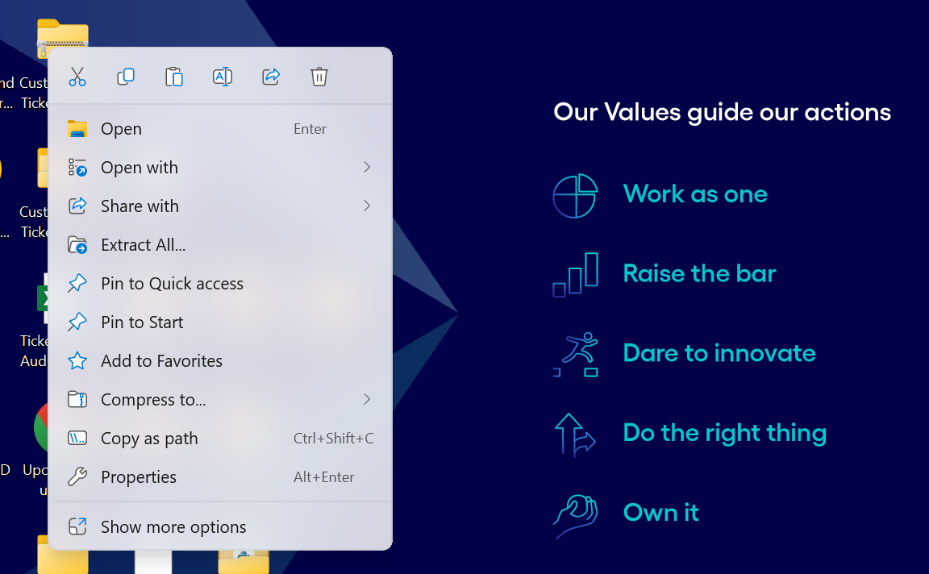

2. ✅ Open Terminal in the extracted folder (Follow Next Image how to open Terminal)
- Right-click on empty space inside the folder
- Select “Open in Terminal”
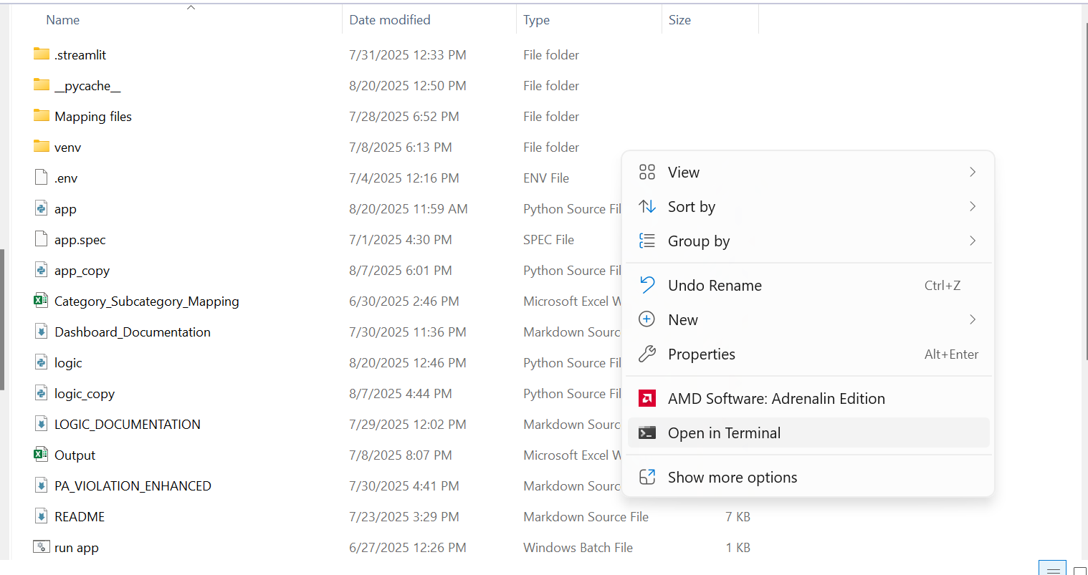

3. ✅ Install required libraries:
First check the Python version.

✔️
If a Python version above 3.9 is available, then Install libraries with this command
python -m pip install streamlit pandas openpyxl plotly
Once you have copied and pasted the above command, please press enter to proceed. 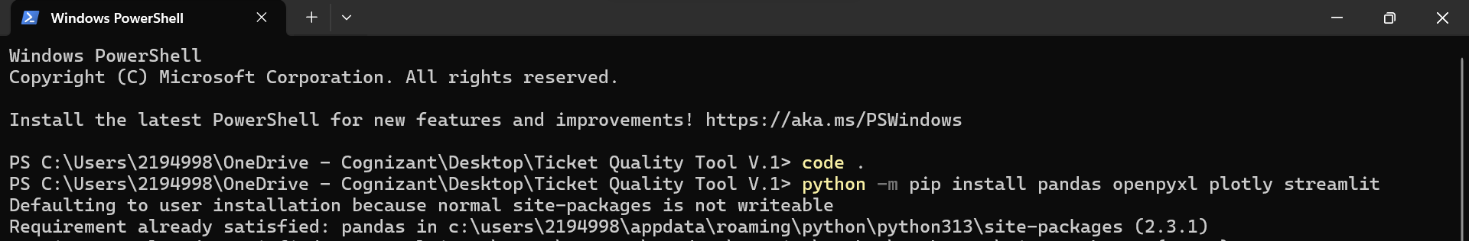

Please ensure all libraries have been installed before proceeding.
4. ✅ Run the app:
Option1 -1:- run manually:
python -m streamlit run app.py
Option1 -2:- OR Double-click the .bat file

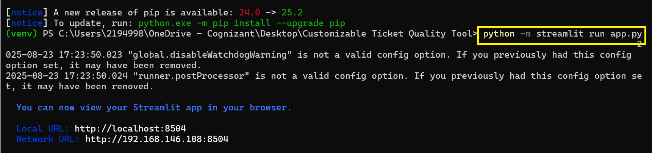
5. 🖥️ The app will open in your browser (http://localhost:8501)

It will look like this and fter this it will launch Browser then you can see the tool And you can use
Note: When you do this for first time it will ask for Email then you provided Email and press Enter or to skip you directly Press Enter
6. 📁 You can now:
- Download the input template
- Fill and upload your ticket data
- Get downloadable output and dashboard
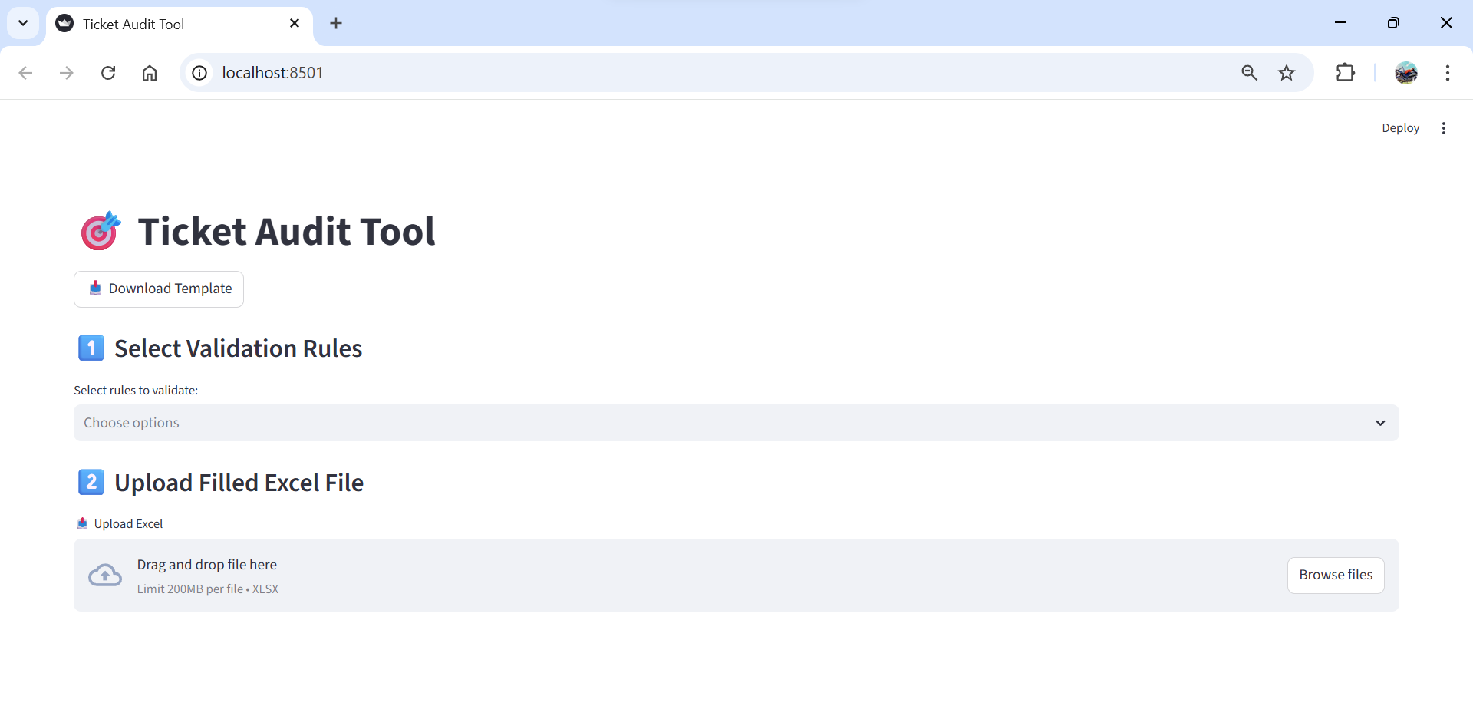
📝 NOTES:
--------
✔️ Works offline. No internet required.
✔️ If app doesn't open, check Python and library installation.

🙋 CONTACT:
-----------
For help, reach out to: Rohit Pagar (2194998@cognizant.com)
Built with Streamlit by Rohit | 2025

